DREAMWEAVER E-PROJECT

 AUTO WORLD.COM

**GROUP MEMBERS SUBMITTED TO**

**Muneeb Farid Sheikh**  [eProjects@aptechfze.ae](mailto:eProjects@aptechfze.ae)

**Student**  **PROJECT INSTRUCTOR**

**Syed Zohaib Ali**  **Miss Mehneemah shafi**

**Student** **CURRICULLUM CODE**

**Syed Daniyal Ali**  **6673**

**Student**

**Muhammad Usama**

**Student**

 AUTO WORLD.COM

**TABLE OF CONTENTS**

ACKNOWLEGDMENT --------------------------------------------------------------------------3

PROJECT CRETIFICATION----------------------------------------------------------------------4

INTRODUCTION TO AUTO WORLD----------------------------------------------------------5

REQUIRMENT SPECIFICATION----------------------------------------------------------------6

(A) HARDWERE REQUIRMENT---------------------------------------------------------------7

(B) SOFTWERE REQUIRMENT---------------------------------------------------------------8

PROJECT DURATION----------------------------------------------------------------------------9

TASK SHEET---------------------------------------------------------------------------------------10

SNAPSHOT-----------------------------------------------------------------------------------------11

 AUTO WORLD.COM

# ACKNOWLEDGEMENT

***W***

*e are thankful to Almighty, ALLAH that by His grace we have been successful. we presenting on* ***Dream Weaver*** *in your hands. We have tried our best to take all relevant important topics in consideration so that this project may become comprehensive.*

*This is our* ***First Year Semester E****-project. We have tried our best & struggled for a better outlook to come. This project has been developed in* ***Dream Weaver.*** *We choose to make Webpage for* ***AUTOWORLD*** *as a project. We find easy to do coding in* ***Dream Weaver.***

*We earnestly hope that this project will provide all the necessarily information required for the user to fulfill their inspiration. However suggestions for improvement of the project will be thankful received & acknowledge.*

 AUTO WORLD.COM

**THANKING YOU……**

 AUTO WORLD.COM

This is to certify that,

Muneeb farid sheikh , Syes Zohaib Ali , Syed Daniyal Ali , Muhammad Usama as

Successfully Designed & Developed “AutoWorld”

 AUTO WORLD.COM

Date of issue:

26/july/2018

Authorized signature: Miss Mehneemah Shafi

 AUTO WORLD.COM

# “INTRODUCTION TO AUTOWORLD”

##### Welcome to AUTOWORLD where you can buy cars of different categories. Automobile industry is one of the most developed industry, since every new car is launched rapidly. AUTOWORLD gives you a plate form where you could not only buy cars but you could get information what is going on in automobile industry. Here are many categories of cars such as hyper cars, sport cars, family cars and electric cars could be bought from dealers around the globe. You can do contact with dealer by given contact information and dealer’s place which makes you feel luxurious and comfort to contact easily with dealer. Although pictures are also added with the contact information and the description of selected car.

**REQUIREMENT SPECIFICATION:**

***AutoWorld.com*** needs to be constructed considering following requirements:

1. Home page which will brief about the company, also design a suitable logo and include it on home page, you may display the logo on all the pages in the site.’
2. A menu which will include all the functions implemented in the site.
3. The user should be able to locate the dealers based on the car brands. e.g. Honda, Suzuki, Ford etc.
4. A catalogue should be provided which will help the users to have a look at car’s image and clicking on the same will display the details about it. The details include features, price, location of the dealer etc.
5. There should be a page for contacting to the company which will include the name, address, phone and email address.
6. Site should also include the page that will give the information about the warranty schemes on the cars. The scheme will be different for the different brands. You are free to develop your own warranty schemes.
7. There should be a page which will list the banks/organizations which provide finance to purchase from AutoWorld. Clicking on the name of the company, user should be redirected to another page which will give the detailed information about the finance scheme. This information will include the details like the maximum amount which customer will get, interest rate, duration in which the amount can be repaid and the installment to be paid and also the terms and conditions.
8. The site should also include the comparison of different cars (same as well as different brands)
9. The user should be able to search the cars based on companies and price.
10. The information about various cars can be picked up from the internet.
11. The site should have appropriate look and feel suitable to company’s reputation and status.

**HARDWARE REQUIRMENT:**

* A minimum computer system that will help you access all the tools in the courses is a Pentium 166 or better
* 64 Megabytes of RAM or better

**SOFTWERE REQUIRMENT:**

* Notepad/HTML editor
* Dreamweaver
* IE 5.0/ Netscape 6.0

DEVELOPER GUIDE

|  |  |  |
| --- | --- | --- |
| NO | ITEMS | DISCRIPTION |
| 01 | Operating System | Windows98,2000,xpetc |
| 02 | Main Processor | Minimum 166 or better |
| 03 | Ram (Memory) | Minimum 64or better |
| 04 | Web Browser | Google Chrome |
| 05 | Software | DreamWeaver |

AUTO WORLD



CONTACT US

Map

brand

Home

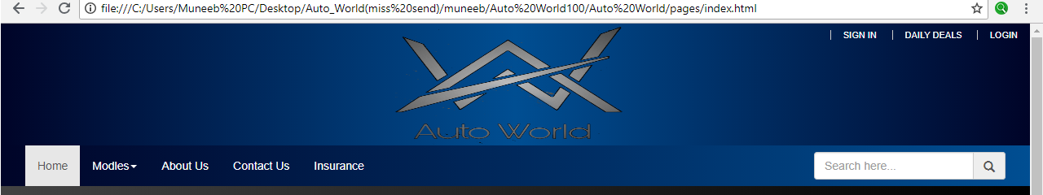

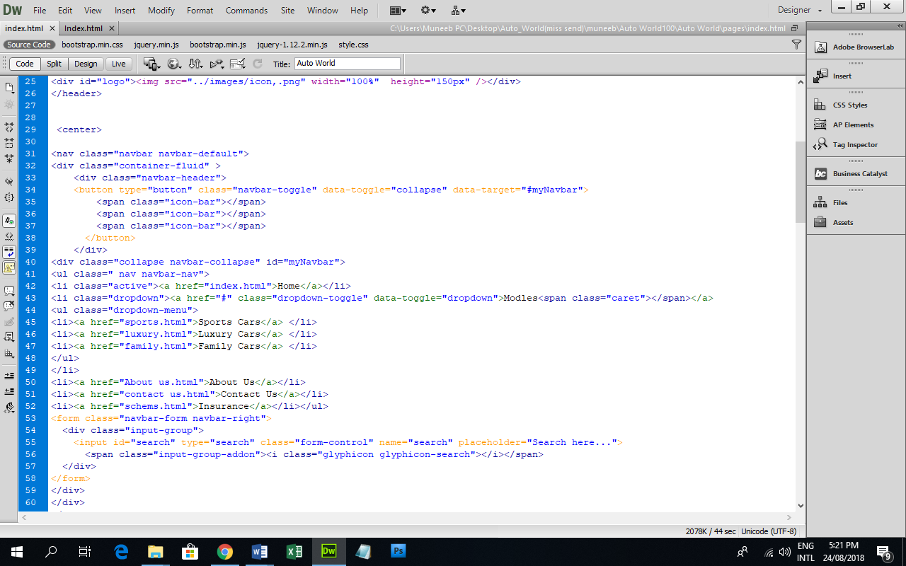

**HOME:**

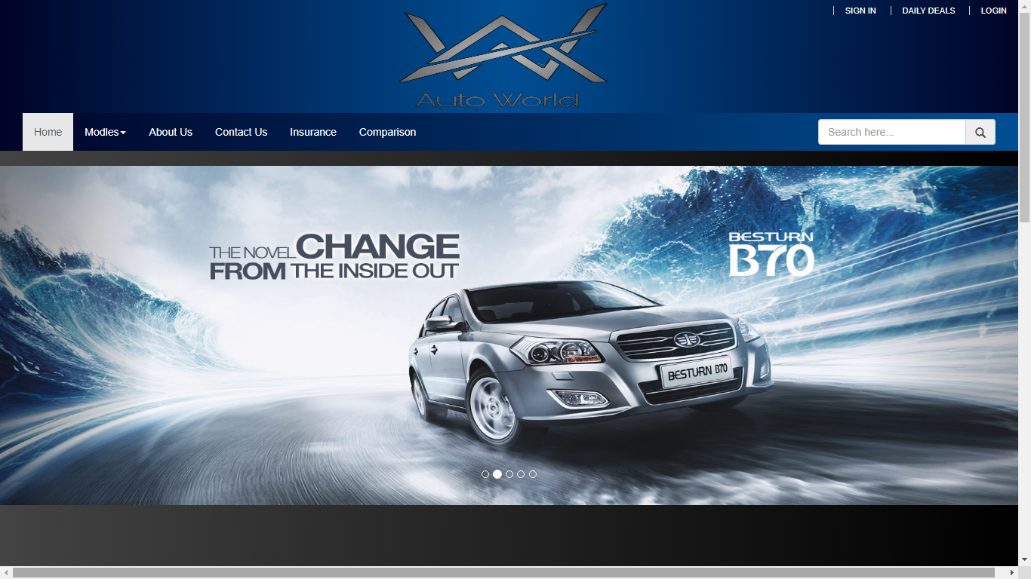

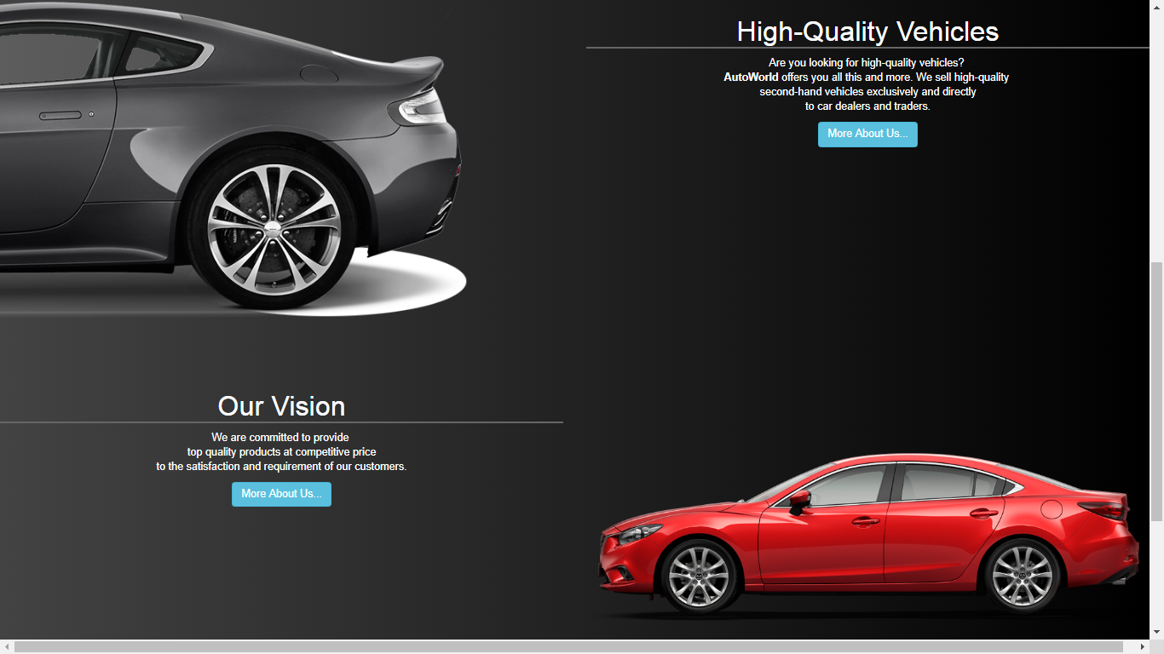

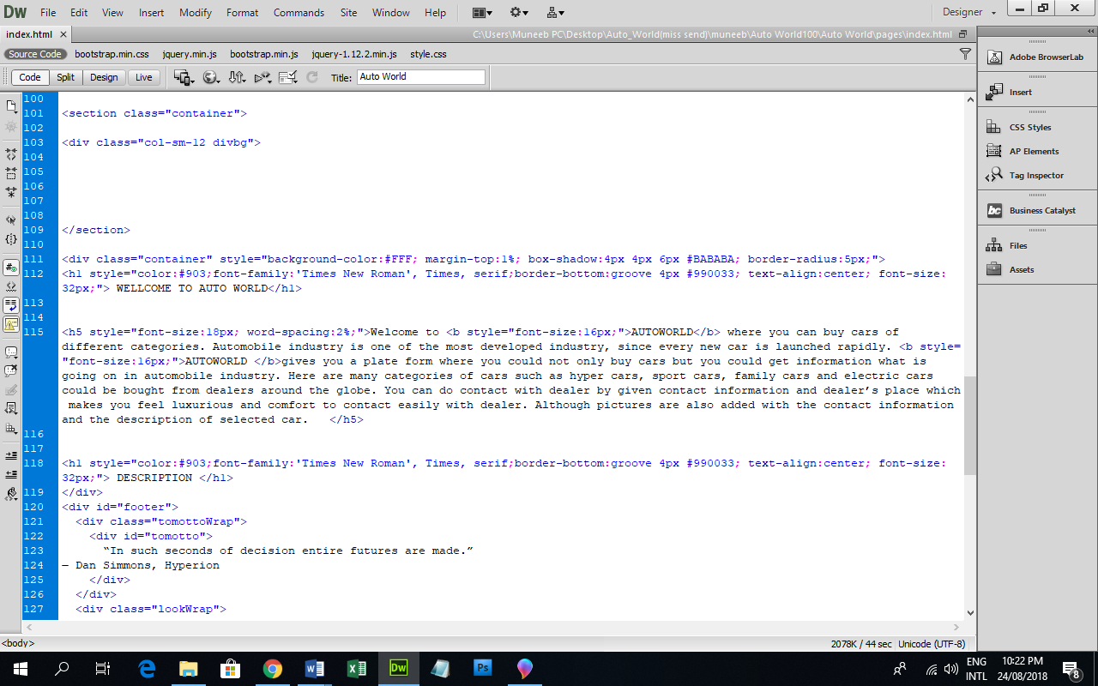

**brand:**

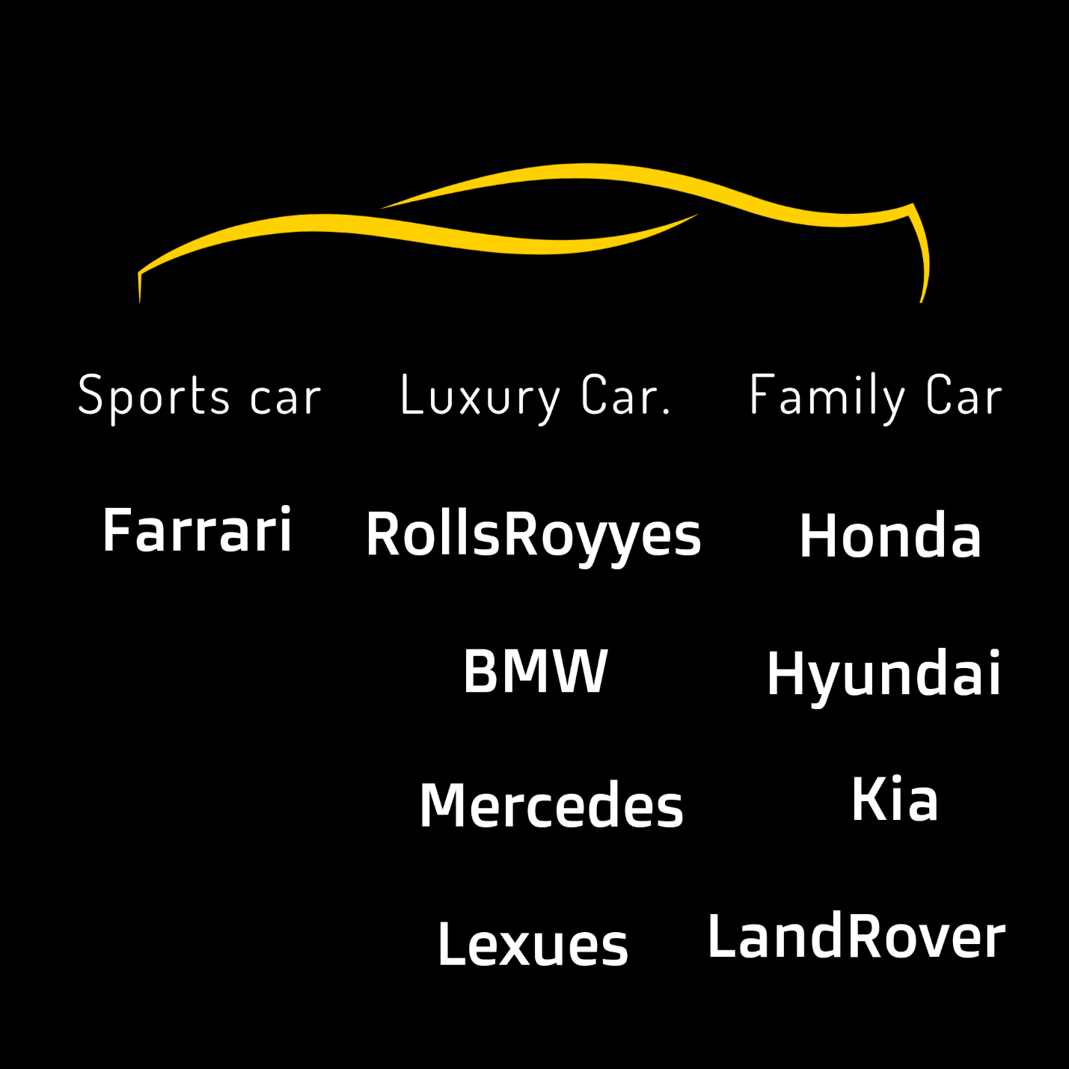

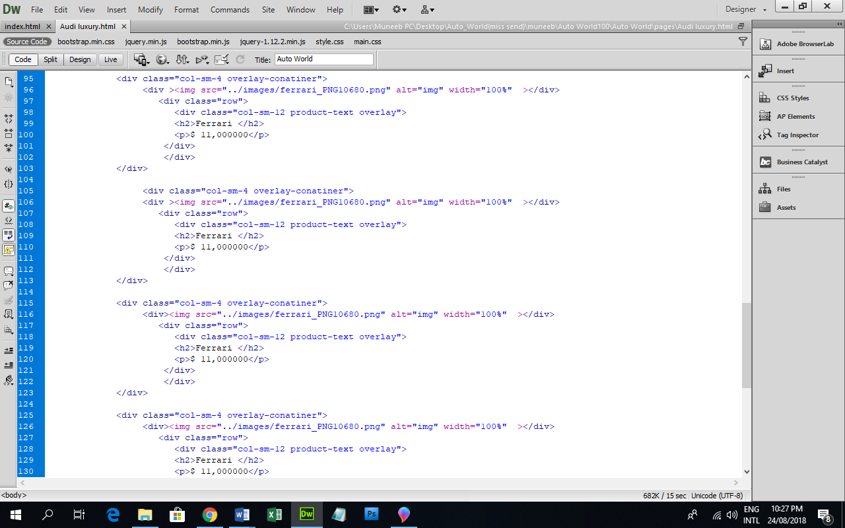

**CONTACT US:**

